Home/Local control of gypsy moth egg masses on individual trees
Remember the flights of gypsy moth adults, mating and laying eggs in our neighbourhoods this past summer? Many of us went out and scraped egg masses from the trunks of trees but we probably didn’t get them all. With the leaves gone, it is now easier to see those egg masses. Before the really cold weather sets in and we have another large snowfall, I encourage you to inspect the trees in your yard and the walls of your house and garden shed.

As a food source, gypsy moths prefer oaks but the moths will lay eggs on, and the caterpillars will eat, aspen/poplar, beech, black locust/acacia, birch, butternut, elm, maple, cherry, apple, pine, spruce, hemlock, tamarack and balsam fir. When the caterpillars hatch in the spring, they will climb upwards in search of leaves. Left untouched, a tree can be defoliated but, that is not necessarily fatal to a deciduous tree.

What to look for and where
The egg mass is a fuzzy tan- to beige-coloured flattened blob, about 2 to 2.5 cm (3/4 of an inch) wide and slightly longer. Look for them on the tree trunk, especially in crevices from right at ground level up as far as you can see, on the undersides of lateral branches, on rocks, lawn furniture and the sides of buildings and wall under-hangs. The dark brown spots on the right are pupae and they too should be removed if you find them unsightly but at this time of year, they are probably empty.

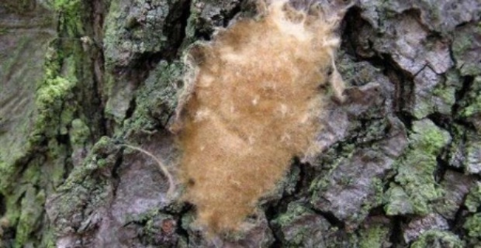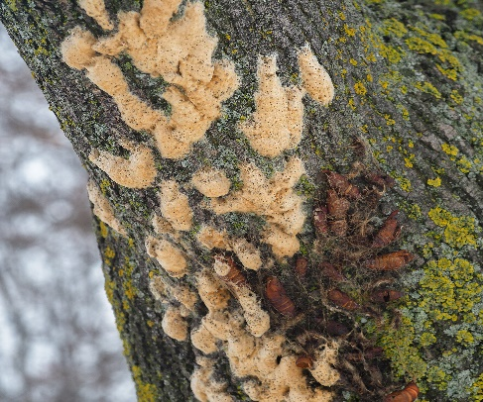
Photo credits: Hopatcong Regional News and City of Toronto

What you need
To collect and safely dispose of the egg masses you will need a margarine/yogurt tub, a dull knife or palette knife, an old toothbrush or stiff small paint brush, a flat “tray” of plastic with a lip on edge (see the picture) and later, when home, liquid dish detergent.

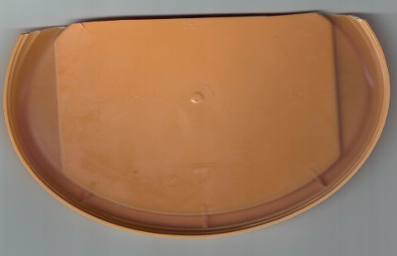
Photo credit: Iola Price

Egg mass removal
Holding the flat edge of the plastic “tray” directly under the egg mass with the lip edge outward, insert the knife at the bottom of the egg mass and gently work the knife upward, lifting the mass away from the tree. Be careful not to damage thin-barked trees such as cherry, beech or birch as this opens the tree to the possibility of infection. With luck and practice,
the egg mass will come off as a complete unit and be held in place by the lip of the plastic tray. Tip the egg mass into the yogurt tub. Then go back and with the toothbrush, gently brush any remaining eggs onto the tray. Eggs that fall to the ground may survive under the snow and hatch out in the spring so pick them up if possible.

If you have egg masses within reach of an extension card a neighbour recommends using a shop vac with a good filter bag. For egg masses high overhead, one can attach a long metal tube to the hose to avoid using a ladder.

Put the eggs masses into a strong mixture of dish-washing detergent and water and leave covered for two days to kill the eggs and then dispose of them in the green bin. If using a shop vac, soak the vacuum bag in soapy water for a few days before disposing of the eggs. Teachers and parents – is this a fun outdoor environmental education opportunity?

What happens next spring: Caterpillar stage: Gypsy moth eggs that do hatch into caterpillars will crawl toward the leaves and start eating. They will descend from the upper branches of the tree, hide at ground level during the heat of the day and then climb back up the trunk to begin feeding on leaves again. At chest level, wrap a tree trunk with a 45 cm strip of burlap. Tie a string around the middle of the burlap and fold the top portion down to form a skirt to trap the caterpillars as they climb upwards. Carefully collect them every day and shake into a detergent and water solution and leave them for two days until they are dead. The long hairs on the caterpillar contain histamines that can cause allergic reactions so wear gloves if you think you will contact the caterpillars.

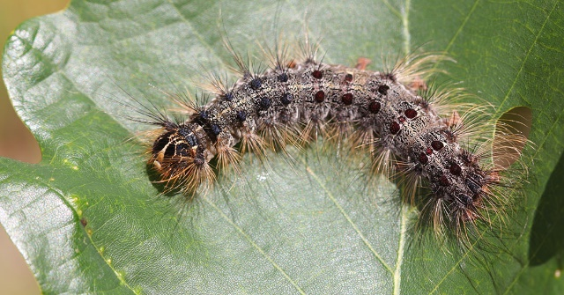
Photo credit: USDA Forest Service

Iola Price

